Business Office Skills Certificate  Program Application  September 18 – December 8, 2017 | 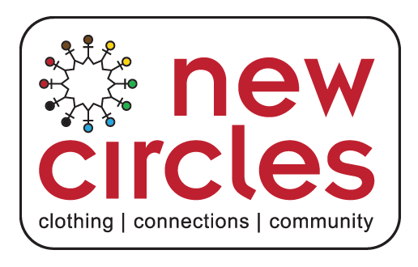

Contact Information
Name
Date of Birth MM / DD/ YYYY
Street Address
Postal Code
Home Phone
Mobile Phone
E-Mail Address
Are you a client of NewCircles
Are you eligible to work in Canada?
Are registered with an Employment Ontario centre? If yes, please provide the name of agency.
Are you a client of Toronto Employment Social Services? If yes, please provide the name of office you are registered with.
Are you currently receiving Employment Insurance benefits?

Availability

Are you available Monday through Friday 9 am – 4 pm during program hours from September to December (12 weeks)?

Y / N
If you are anticipating any absences during this period, please explain below:

Program Interest

Tell us why you are interested in the Business Office Skills program.

Participation

Are you currently job searching? Y / N
Please explain how you do your job search: ___________________________________

Are you able, willing and interested in working in entry-level administration and customer service positions upon completion of this program? Y / N
If no, please explain: __________________________________

New Circles will cover all costs related to books and tuition.
We do not cover transportation costs. Are you able to be transported 5 days a week for 12 weeks to New Circles and your placement? Y / N
If no, please explain: __________________________________

Skills or Qualifications

Summarize special skills and qualifications you have acquired from employment, previous volunteer work, or through other activities, including hobbies related to administrative skills (reception, data entry, Microsoft Office etc.) and customer service.

Person to Notify in Case of Emergency
Name
Phone
E-Mail Address

Agreement and Signature

By submitting this application, I affirm that the facts set forth in it are true and complete. I understand that if I am accepted as a student, any false statements, omissions, or other misrepresentations made by me on this application may result in my immediate dismissal.
Name (printed)
Signature
Date

Please fill it out electronically and email it back to us along with your resume (MS Word document).

Will be used by New Circles

Date: ____________________________________________

Applicant Name: ____________________________________________

Staff Name: ____________________________________________

- ELIGIBLE TO WORK IN CANADA: PR, Citizen, Waiting for PR, Other
- Income Source: __________________________________________
 EO FORMS
 SHARED CONSENT
 BOS APPLICATION
 RESUME
 TYPING TEST
 MATH TEST
 ENGLISH TEST
 INTERVIEW

REVIEW WITH APPLICANT
 More than 2 program absences will result in termination from program.
 Transportation to both New Circles and Placement is responsibility of applicant; cannot guarantee preferred location of placement.
 Costly program to deliver; only those who are fully able to commit to 12 weeks and are actively job searching should participate.
 Tentatively scheduled between September - December 2017.
 Applicant will be informed by end of August and will be given one week to make a decision to accept or decline.
 NC provides support with training, skills development and job search; Students will also be expected to participate in an independent job search
 Confirm completion of Grade 12; Are you able to present diploma?

